A

Project Report on

**“ HYPERLOOP TRANSPORT TECHNOLOGY ”**

Submitted in partial fulfillment of the requirements for the award of the degree of

**BACHELOR OF TECHNOLOGY**

In

**ELECTRONICS AND COMMUNICATION ENGINEERING**

*Submitted by*

**P,PURUSHOTHAM (19AK1A04C5)**

Under the esteemed guidance of

**Mr.J.GURUNADHAN,**

Associate Professor, Dept. of ECE



**ELECTRONICS AND COMMUNICATION ENGINEERING**

**ANNAMACHARYA INSTITUTE OF TECHNOLOGY AND SCIENCES**

**(AUTONOMOUS)**

(Approved by AICTE, New Delhi & Permanent Affiliation to JNTUA, Anantapuramu.

Two B. Tech Programmes (CSE & ECE) are accredited by NBA, New Delhi. Accredited by NAAC with 'A' Grade, Bangalore. Accredited by Institution of Engineers (India), KOLKATA. A-grade awarded by AP Knowledge Mission. Recognized under sections 2(f) & 12(B) of UGC Act 1956.) Tirupati- 517520.

2022-2023

**ANNAMACHARYA INSTITUTE OF TECHNOLOGY AND SCIENCES**

**(AUTONOMOUS)**

(Approved by AICTE, New Delhi & Permanent Affiliation to JNTUA, Anantapuramu.

Two B. Tech Programmes (CSE & ECE) are accredited by NBA, New Delhi. Accredited by NAAC with 'A' Grade, Bangalore. Accredited by Institution of Engineers (India),

KOLKATA. A-grade awarded by AP Knowledge Mission. Recognized under sections 2(f) & 12(B) of UGC Act 1956.) Tirupati- 517520.

**ELECTRONICS AND COMMUNICATION ENGINEERING**



CERTIFICATE

This is to certify that the socially relevant project work entitled,**“HYPERLOOP**

**TRANSPORT TECHNOLOGY”**, done by **P,PURUSHOTHAM (19AK1A04C5)** is being submitted in partial fulfillment of the requirements for the award of the degree of **BACHELOR OF TECHNOLOGY** in **ELECTRONICS AND COMMUNICATION ENGINEERING** to the AnnamacharyaInstitute of Technology and Science, Tirupati, is a record of bona fide work carried out by them under my guidance and supervision. The results embodied in this socially relevant project report have not been submitted to any other university or institute for the award of any degree or diploma.

Signature of the Supervisor Signature of the Head of the Department

**Mr.J.Gurunadhan.,** **Dr. N. Pushpalatha, M.Tech., Ph.D.,**

Associate Professor, Professor& Head, Dept. of E.C.E. Dept. of E.C.E.

DATE:

**ACKNOWLEDGEMENTS**

It is our insightful duty and pleasure to express our gratitude to all those who helped us in completion of this work successfully.

We would like to express our sincere gratitude to our supervisor **Mr.J.GURUNADHAN**, Associate Professor, Department of ECE, AITS, Tirupati, for his constant help, kind co-operation and encouragement in completing the work successfully. we are thankful for his careful verification of the manuscript in spite of his busy schedule.

We are very much thankful to all the Internal Departmental Committee members for their valuable suggestions in all the reviews and letting our work to go smoothly. We are thankful to all my B. Tech Colleagues for their cooperation and faculty members, Lab Technicians for their support in completion of our work.

We would like to thank **Dr. N. Pushpalatha**, Head, Department OF ECE for giving permission to do the project work in the college and for her scholarly support throughout the project.

It is our pleasure to express sincere thanks to **Prof. C. Nadhamuni Reddy**, Principal,

Annamacharya Institute of Technology & Sciences, Tirupati and **Sri. C. Gangi Reddy**,

Hon’ Secretary of Annamacharya Educational Trust for providing good infrastructure and facilities in our college.

Last but not least we feel more responsible to express our sincere thanks to friends and family members for their moral support, time without which the successful completion of the work would not have been possible.

**P.PURUSHOTHAM (19AK1A04C5)**

# CONTENTS

Page No.

|  |  |  |
| --- | --- | --- |
|  | Acknowledgement |  |
|  | List of Figures |  |
|  | List of Tables |  |
| **1.** | **INTRODUCTION** |  |
|  | * 1. Introduction   1.2 Background Information on Hyperloop Transport Technology |  |
| **2.** | **TECHNICAL ASPECTS OF HYPERLOOP TRANSPORT TECHNOLOGY** |  |
|  | 2.1 Design and Construction of Hyperloop Tubes  2.2 Propulsion Systems for Hyperloop Vehicles  2.3 Levitation and Guidance Systems for Hyperloop Vehicles  2.4 Safety and Security Measures for Hyperloop Transport Technology |  |
| 3**.** | **ECONOMIC ASPECTS OF HYPERLOOP TRANSPORT TECHNOLOGY** |  |
|  | 3.1 Cost and Financing of Hyperloop Systems  3.2 Potential Market for Hyperloop Transport Technology  3.3 Economic Impact of Hyperloop Transport Technology |  |
|  | 4.1 Regulatory Framework for Hyperloop Transport Technology  4.2 Legal and Liability Issues Related to Hyperloop Transport Technology  4.3 Intellectual Property Considerations for Hyperloop Technology |  |
| **5.** | **Environmental Aspects of Hyperloop Transport Technology** |  |
|  | 5.1 Environmental Impacts of Hyperloop Systems  5.2 Sustainable Development Potential of Hyperloop Transport Technology |  |
| **6.** | **Case Studies of Hyperloop Transport Technology Projects** |  |
|  | 6 .1 Hyperloop One  6.2 TransPod  6.3 Delft Hyperloop |  |
| **7.** | CONCLUSION |  |
|  | 7.1 Summary of Key Findings  7.2 Future Prospects for Hyperloop Transport Technology |  |
| **8.** | REFERENCES |  |

Appendix

# LIST OF FIGURES

|  |  |  |
| --- | --- | --- |
| **FIG. NO.** | **NAME OF THE FIGURE** | **PAGE NO.** |
| 1.1 | Space Debris growth yearly | 4 |
| 1.2 | Satellites in Orbit | 5 |
| 2.1 | Kessler Syndrome | 8 |
| 4.1 | Electro Dynamic Tether and Laser Ablation | 15 |
| 4.2 | Robotic arm and Net | 16 |
| 4.3 | Capturing and De Orbit Process | 16 |
| 5.1 | ESA Ground based and space-based space debris monitoring technology | 20 |
| 5.2 | Optical imaging ***(center)***, radar imaging ***(left)*** and lidar ***(right)*** | 21 |
| 5.3 | ML and AI in space debris monitoring and tracking | 22 |
| 6.1 | Countries and Space Junk | 25 |
| 6.2 | Wood Satellite | 27 |

**CHAPTER-1**

**CHAPTER-1**

# INTRODUCTION

Hyperloop is a proposed mode of transportation that uses sealed tubes or tunnels to transport people and goods at very high speeds. The concept was first introduced in 2013 by Elon Musk, the CEO of SpaceX and Tesla, as a faster and more efficient alternative to traditional modes of transportation, such as planes, trains, and automobiles.The hyperloop system works by using a combination of vacuum-sealed tubes, magnetic levitation, and air bearings to propel passenger or cargo pods through the tubes at high speeds, potentially reaching speeds of over 1000 km/h (600 mph). The pods would be designed to carry passengers or cargo and would travel in a low-pressure environment, reducing air resistance and allowing for faster speeds.

Several companies have been working to develop and test hyperloop technology, including Virgin Hyperloop, Hyperloop Transportation Technologies, and Elon Musk's own company, The Boring Company. While the concept of hyperloop transportation is still in the experimental phase, proponents believe that it has the potential to revolutionize the way people and goods are transported, offering faster and more efficient travel while reducing carbon emissions and congestion on traditional transportation systems.

The idea behind the Hyperloop is to create a system that is faster, cheaper, and more energy-efficient than existing modes of transportation, such as planes, trains, and cars. The pods are designed to travel at speeds of up to 760 miles per hour, which is faster than most commercial planes. They would also be able to make the trip from Los Angeles to San Francisco in just 30 minutes.

Hyperloop is based on a principle of magnetic levitation. The principle of magnetic levitation is that a vehicle can be suspended and propelled on a guidance track made with magnets. The vehicle on top of the track may be propelled with the help of a linear induction motor.

* 1. **Background Information on Hyperloop Transport Technology**

Hyperloop transport technology is a concept proposed by entrepreneur Elon Musk in 2013. It is a mode of transportation that involves high-speed travel in a sealed tube or tunnel, where low pressure or vacuum is maintained to reduce air resistance and friction. Hyperloop transport technology involves using magnetism to levitate and propel a passenger or cargo pod through a tube, with the goal of achieving speeds of up to 760 miles per hour (1,223 kilometers per hour) or more. The technology aims to provide faster, safer, and more efficient transportation for long distances, with the potential to rival the speed and convenience of air travel while being more sustainable and environmentally friendly.

Since the concept was introduced, several companies and organizations have been working on developing and testing hyperloop transport technology. Some of the key players in the industry include Virgin Hyperloop (formerly Hyperloop One), TransPod, and Delft Hyperloop. These companies have conducted successful tests of their hyperloop technology prototypes, and several hyperloop projects are currently in the planning and development stages in various parts of the world. Despite the progress made in developing hyperloop transport technology, there are still several technical, economic, legal, and environmental challenges that need to be addressed before the technology can be widely implemented.

avels at extremely high speeds, and even small objects can cause significant damage if they collide with a satellite or spacecraft. Collisions with space debris can cause mission failures, damage to critical systems, and even pose a risk to the lives of astronauts.

1. **Generation of more debris:** Collisions between space debris can generate even more debris, creating a self-sustaining cycle that increases the amount of debris in orbit.
2. **Interference with communication networks:** Space debris can interfere with communication networks, including those used for satellite communication, navigation, and weather forecasting.
3. **Risk to terrestrial infrastructure:** As the amount of space debris continues to grow, it poses a risk to terrestrial infrastructure, including communication networks and other critical systems.
4. **Cost:** The cost of designing and operating systems to protect against space debris can be significant, and can add to the cost of space missions and satellite launches.

Efforts to address the problem of space debris have included developing methods for removing debris from orbit, as well as designing new spacecraft and launch vehicles that produce less debris. However, the issue of space debris remains a significant challenge for the space industry and will require continued efforts to mitigate its risks.

## 1.3 ORIGINS AND GROWTH OF SPACE DEBRIS

The origins of space debris can be traced back to the beginning of the space age, with the launch of the first artificial satellite, Sputnik 1, by the Soviet Union in 1957. This marked the beginning of a new era in space exploration, as countries around the world began to develop and launch their own spacecraft. As the number of objects in orbit increased, so too did the amount of debris generated by those objects. In the early days of the space age, the risks posed by space debris were not fully understood, and little effort was made to track or mitigate the problem.

The growth of space debris has been a significant problem since the beginning of the space age. As more and more objects have been launched into orbit, the amount of debris generated by these objects has continued to grow. In the early days of the space age, the risks posed by space debris were not fully understood, and little effort was made to track or mitigate the problem. However, over time, as the amount of space debris grew, the risks became more apparent. Problem of space debris is a significant concern for the global space community. According to the U.S. Space Surveillance Network, there are over 27,000 pieces of debris larger than 10 cm in orbit, and many more smaller pieces that are more difficult to track. This debris is distributed across a range of altitudes and orbits, increasing the risk of collisions and other accidents. The growth of space debris has been fueled by a variety of factors, including the increasing number of objects in orbit, the use of non-degradable materials in spacecraft and launch vehicles, and the lack of international regulations and standards for the disposal of space debris.

**1956 1991 2015 2030??**

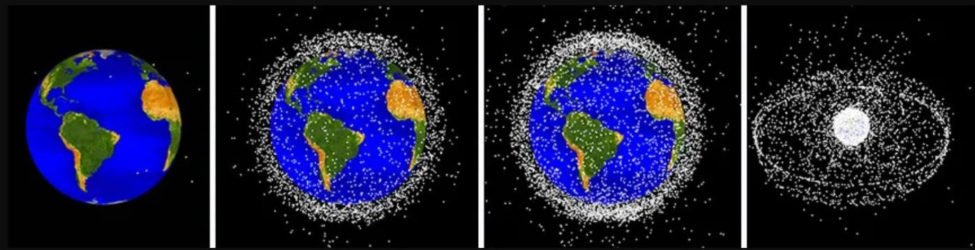

**Fig.1.1: Space Debris growth yearly**

## 1.4 TYPES AND SIZES OF SPACE DEBRIS

In Space debris comes in a variety of shapes and sizes, ranging from small flecks of paint to entire defunct spacecraft.

1. **Macro debris:** This type of debris is typically larger than 10 cm in size and includes objects such as defunct satellites, rocket bodies, and fragments from collisions or explosions. These objects pose the greatest risk to operational spacecraft and the International Space Station.
2. **Micro debris:** This type of debris is usually less than 10 cm in size and includes small fragments of paint, insulation, and other materials. While these objects are too small to pose a significant risk to operational spacecraft, they can still cause damage and add to the overall amount of debris in space.
3. **Nano debris:** This type of debris is less than 1 cm in size and includes even smaller particles, such as dust and flecks of paint. While these objects are too small to be tracked individually, they can still cause damage and contribute to the overall amount of debris in space.

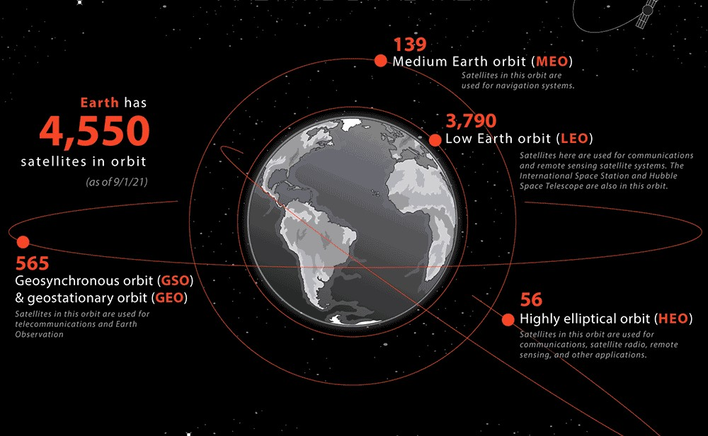

#### Fig.1.2: Satellites in Orbit

The size of space debris is an important factor in determining the risk it poses to operational spacecraft. Larger objects are easier to track and pose a greater risk of collision, while smaller objects can be more difficult to detect and can cause more localized damage.

It is important to note that the majority of space debris is in low Earth orbit, where most satellites and other objects are located. However, debris can also be found in higher orbits and in geostationary orbit, where many communication satellites are located. The distribution of debris across different orbits further complicates efforts to track and mitigate the problem.

**CHAPTER-2**

**CHAPTER 2**

# RISKS AND IMPACT OF SPACE DEBRIS

Space debris poses a significant risk to operational spacecraft and satellites, as collisions can result in mission failure, damage, and loss of life. The Kessler Syndrome, a theoretical scenario in which collisions between space debris lead to a cascade of collisions and the generation of even more debris, is a growing concern for the long-term sustainability of human activities in space. In addition, space debris has economic and environmental impacts, as it can damage infrastructure and lead to the release of hazardous materials into the atmosphere.

## 2.1 IMPACT OF SPACE DEBRIS ON OPERATIONAL SATELLITES AND HUMAN ACTIVITIES IN SPACE

Space debris poses a significant risk to operational satellites and human activities in space. Operational satellites are at risk of collisions with space debris, which can cause damage or even complete destruction of the satellite. The impact of a collision with a small object can create a hole in the satellite, while a collision with a larger object can break the satellite into many pieces, adding to the amount of debris in orbit. This can disrupt vital services such as communication, navigation, and weather forecasting.

Human activities in space are also at risk from space debris. Astronauts on the International Space Station must be constantly aware of the risk of debris impacts and take precautions to minimize their risk, such as sheltering in designated safe areas during periods of heightened risk. Future crewed missions to the Moon and Mars will also face the risk of debris impacts during transit.

In addition to the direct risks to operational satellites and human activities, space debris can also have indirect impacts on space activities. For example, the increasing amount of debris in orbit makes it more difficult and costly to launch new spacecraft, as they must be designed with additional shielding and protection against debris impacts. It can also increase the risk of accidental collisions between satellites, further exacerbating the problem.

## 2.2 RISKS OF COLLISIONS AND THE KESSLER SYNDROME

The increasing amount of space debris in orbit poses a significant risk of collisions, which can have serious consequences for operational satellites, future space missions, and even human life on Earth.

1. **Operational satellites:** Collisions between space debris and operational satellites can cause significant damage or even complete destruction of the satellite. Even small debris can create a hole in the satellite, while larger debris can break it into many pieces, adding to the amount of debris in orbit. This can disrupt vital services such as communication, navigation, and weather forecasting.
2. **Future space missions:** Collisions with space debris are also a significant risk to future space missions. The debris can damage or destroy spacecraft during launch, transit, or landing. This can result in loss of equipment, data, and even human life
3. **Human life on Earth:** Space debris can also pose a risk to human life on Earth. Larger debris can survive re-entry into the Earth's atmosphere and impact the ground, potentially causing damage or injury. Although the likelihood of this occurring is low, the risk is still present.

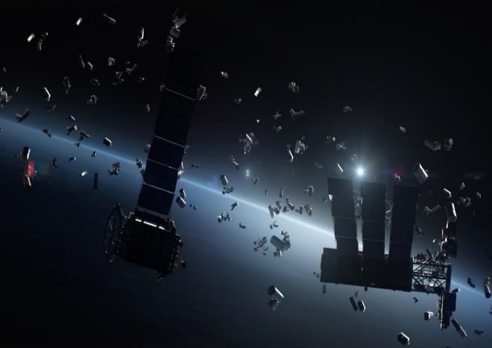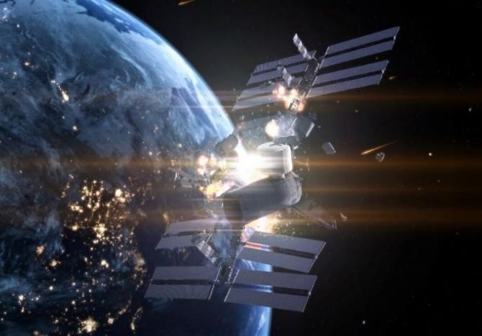

#### Fig.2.1: Kessler Syndrome

The risks of collisions highlight the urgent need for action to address the problem of space debris. Efforts to track and monitor debris in orbit are essential to identify potential collisions and minimize the risk to operational satellites and future space missions. Measures to mitigate the creation of new debris, such as designing satellites with end-of-life disposal plans, and the development of active debris removal technologies are important steps towards reducing the amount of debris in orbit and mitigating the risk of collisions.

The Kessler Syndrome is a theoretical scenario in which the amount of space debris in orbit is so great that collisions between objects create a cascading effect, leading to a runaway chain reaction of collisions and the creation of even more debris. This could result in the entire region of space around the Earth becoming unusable for future space activities, including launching new spacecraft and satellites.

To prevent the Kessler Syndrome from occurring, it is important to take proactive measures to reduce the amount of space debris in orbit and to prevent the creation of new debris. This can be achieved by designing satellites with end-of-life disposal plans, using propellants that minimize the amount of debris generated during launches, and encouraging international collaboration to develop new technologies for removing debris from orbit.

## 2.3 ECONOMIC AND ENVIRONMENTAL IMPACT OF SPACE DEBRIS

The growing amount of space debris in orbit has significant economic and environmental impacts. These impacts range from the direct damage caused by collisions between debris and operational satellites, to the indirect economic losses incurred due to the interruption of satellite services, and the environmental costs of degrading the space environment. One of the primary economic impacts of space debris is the risk of collision with operational satellites. Collisions can cause direct damage to satellites, leading to the loss of critical services such as GPS navigation, satellite-based communications, and Earth observation data. Such disruptions can have significant economic consequences, particularly for industries that rely heavily on satellite services, such as telecommunications, weather forecasting, and military operations. The environmental impact of space debris is also a growing concern. The accumulation of debris in orbit contributes to the degradation of the space environment, which can have long-term consequences for future space activities. Debris can create hazards for spacecraft, making it difficult to safely navigate through orbit, and increasing the risk of collisions. The debris can also re-enter the Earth's atmosphere, posing a risk to people and property on the ground.

To mitigate the economic and environmental impacts of space debris, it is essential to develop effective strategies for removing debris from orbit and preventing the creation of new debris. By taking proactive measures to address the problem of space debris, we can help to ensure the continued use of space for peaceful and productive purposes.

**CHAPTER-3**

Page

**CHAPTER-3**

# OVERVIEW OF SPACE DEBRIS MITIGATION GUIDELINES AND POLICIES

There are various international and national guidelines and policies for space debris mitigation, such as the United Nations Space Debris Mitigation Guidelines and the InterAgency Space Debris Coordination Committee (IADC) Space Debris Mitigation Guidelines. These guidelines promote the adoption of measures to prevent the creation of new debris and to remove existing debris from orbit. Organizations such as NASA, ESA, and JAXA play important roles in the management of space debris, including the development of technologies and best practices for debris mitigation.

## 3.1 OVERVIEW OF INTERNATIONAL AND NATIONAL GUIDELINES AND POLICIES FOR SPACE DEBRIS MITIGATION

International and national guidelines and policies have been developed to address the issue of space debris and promote sustainable space operations. These guidelines and policies provide recommendations and best practices for spacefaring nations and commercial entities to mitigate the creation of new debris, remove existing debris, and prevent collisions. At the international level, the United Nations has played a critical role in developing guidelines and policies for space debris mitigation. The UN Committee on the Peaceful Uses of Outer Space (COPUOS) has developed a set of guidelines for the long-term sustainability of outer space activities. These guidelines provide recommendations for reducing the generation of debris, limiting the growth of debris, and improving the safety of space operations.

International & national guidelines and policies play a critical role in promoting sustainable space operations and mitigating the impact of space debris. By working together to implement best practices for debris mitigation and removal, we can help to ensure the continued use of space for peaceful and productive purposes.

## 3.2 REGULATIONS AND STANDARDS FOR THE PREVENTION OF SPACE DEBRIS

In order to prevent the creation and proliferation of space debris, several regulations have been established at both the international and national levels. These regulations cover a wide range of topics, from the design and operation of spacecraft to the disposal of space systems at the end of their operational life. The following are some of the key regulations that have been established for the prevention of space debris:

1. **Space Debris Mitigation Guidelines:** The Inter-Agency Space Debris Coordination Committee (IADC) has developed a set of guidelines for the mitigation of space debris. These guidelines provide recommendations for the design and operation of space systems to minimize the creation and proliferation of debris. The guidelines cover areas such as the design of spacecraft, the conduct of space operations, and the disposal of spacecraft at the end of their operational life.
2. **International Organization for Standardization (ISO) Standards:** The ISO has developed a series of standards for the design and operation of space systems. These standards cover areas such as the design and manufacture of spacecraft, the operation of space systems, and the disposal of spacecraft at the end of their operational life.
3. **The Indian Space Research Organization (ISRO):**  ISRO is a member of the IADC and follows the regulations and standards developed by the organization for the prevention and mitigation of space debris. ISRO has also developed its own set of regulations and guidelines for the mitigation of space debris, Space debris mitigation guidelines, collision avoidance and debris mitigation and end-of-life disposal of spacecraft and launch vehicle upper stages.
4. **NASA Guidelines:** The National Aeronautics and Space Administration (NASA) has developed a set of guidelines for the mitigation of space debris. These guidelines cover areas such as the design of spacecraft, the operation of space systems, and the disposal of spacecraft at the end of their operational life.
5. **Space Data Association (SDA) Guidelines:** The SDA is an international association of satellite operators that has developed a set of guidelines for the mitigation of space debris. These guidelines cover areas such as the coordination of space operations, the exchange of satellite tracking data, and the disposal of spacecraft at the end of their operational life.

These regulations and standards play a critical role in promoting responsible space operations and mitigating the impact of space debris. By adhering to these guidelines and standards, spacefaring nations and commercial entities can help to ensure the long-term sustainability of space operations and reduce the risk of collisions with space debris.

## 3.3 ROLES OF DIFFERENT ORGANIZATIONS IN THE MANAGEMENT OF SPACE DEBRIS

There are various international and national organizations that play important roles in the management of space debris. These organizations are responsible for developing and implementing policies and regulations, conducting research and analysis, and promoting international cooperation to address the issue of space debris. Some of the most important organizations involved in the management of space debris are:

1. **United Nations Office for Outer Space Affairs (UNOOSA):** UNOOSA is the primary international organization responsible for promoting the peaceful uses of outer space and ensuring the long-term sustainability of space activities. UNOOSA works closely with the Committee on the Peaceful Uses of Outer Space (COPUOS) to develop and implement policies and guidelines related to space debris mitigation and the long-term sustainability of outer space activities.
2. **Inter-Agency Space Debris Coordination Committee (IADC):** The IADC is a forum for international cooperation on space debris issues. It brings together space agencies and other organizations from around the world to coordinate activities related to the mitigation of space debris, including research, analysis, and the development of guidelines and standards.
3. **National Aeronautics and Space Administration (NASA):** NASA is the primary space agency of the United States and is responsible for a significant portion of the debris currently in orbit. The agency plays a key role in the development of technologies and policies related to space debris mitigation, including the development of the Orbital Debris Program Office, which is responsible for research and analysis related to space debris.

These organizations work together to address the issue of space debris through the development of policies and guidelines, the conduct of research and analysis, and the promotion of international cooperation. By working together, these organizations can help ensure the long-term sustainability of space activities and minimize the risks associated with space debris.

**CHAPTER-4**

**CHAPTER 4**

# TECHNIQUES FOR REMOVING SPACE DEBRIS

There are different techniques for removing space debris, including active debris removal techniques, de-orbiting techniques, orbital disposal techniques, and laser-based and electrodynamic tether-based techniques. Active debris removal involves capturing and removing debris from orbit, while de-orbiting techniques involve the use of propulsion systems to bring objects out of orbit and into the Earth's atmosphere, where they will burn up on reentry. Orbital disposal techniques involve placing objects in a graveyard orbit or a disposal orbit, while laser-based and electrodynamic tether-based techniques involve using lasers and electric fields to remove debris from orbit. Each technique has advantages and limitations and can be used in different situations. Combination of these debris removal techniques may be required to effectively mitigate the space debris problem.

## 4.1 ACTIVE DEBRIS REMOVAL (ADR) TECHNIQUES

Active debris removal (ADR) techniques refer to those methods that actively capture and remove space debris from orbit. ADR techniques are considered as one of the most effective ways to control and mitigate the growing space debris problem. Some of the techniques used in active debris removal are:

1. **CAPTURE AND DE-ORBIT:** This technique involves capturing the debris and then deorbiting it to burn up in the Earth's atmosphere. The capture can be done using a robotic arm, Net, Ion beam shepherd and harpooning then the debris is released from its original orbit and moved to a lower orbit where it will re-enter the Earth's atmosphere and burn up.

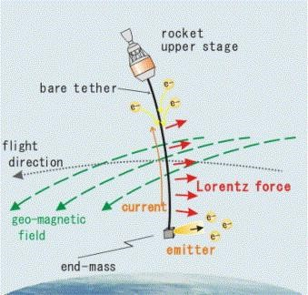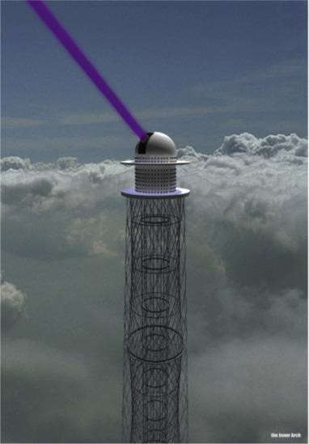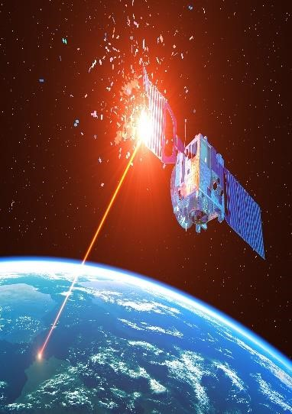

**Fig.4.1: Electro Dynamic Tether and Laser Ablation**

1. **ELECTRODYNAMIC TETHER:** An electrodynamic tether is a long wire that generates an electromagnetic force when it interacts with the Earth's magnetic field. When deployed, the tether can capture debris and then use the electromagnetic force to slow it down, bring it into a lower orbit and causes it to re-enter the Earth's atmosphere.
2. **LASER ABLATION:** This involves using a high-powered laser to vaporize the surface of the debris, which then creates a small amount of thrust that can slow down the debris and cause it to re-enter the Earth's atmosphere.

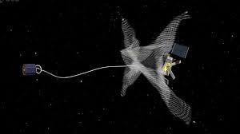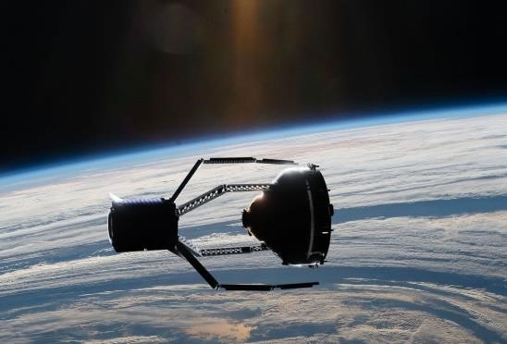

#### Fig.4.2: Robotic arm and Net

**4. ROBOTIC MISSIONS:** Robotic missions involve sending a spacecraft to capture the debris and bring it back to Earth or move it into a safe orbit. This technique is more complex and expensive than the other techniques, but it is useful for capturing larger objects or objects in difficult orbits.

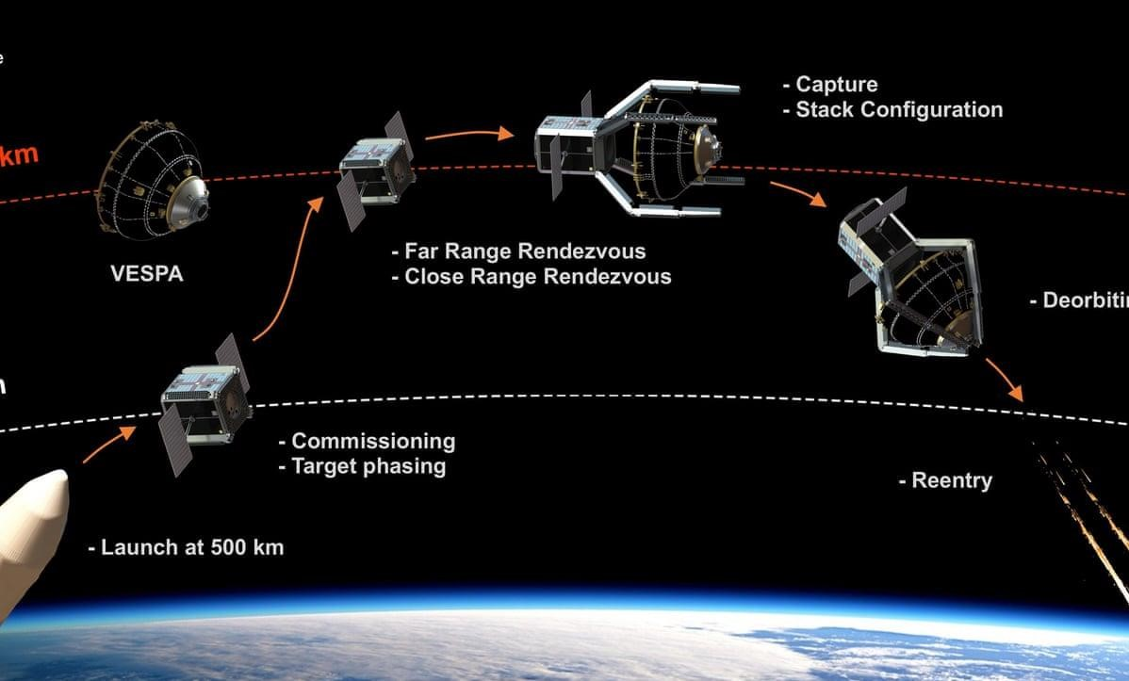

**Fig.4.3: Capturing and De Orbit Process**

## 4.2 PASSIVE DEBRIS REMOVAL TECHNIQUES

Passive debris removal involves the use of materials or devices that cause debris to naturally decay or de-orbit, burn up in the Earth's atmosphere or to stay in orbit for long periods without contributing to the space debris problem. Some of the techniques used in passive debris removal are:

1. **Whipple shield & Drag sail:** This involves using a protective shield around a satellite to absorb the impact of small debris particles, preventing damage to the satellite. Drag sail involves using a large, lightweight sail that creates drag and causes the satellite to slow down and de-orbit.
2. **Lifetime Extension:** Satellites are designed with a limited lifespan after which they will become space debris. By designing satellites to have longer lifespans, fewer objects will need to be replaced, reducing the amount of space debris generated.
3. **Design for Demise:** Satellites can be designed to burn up completely upon re-entry into the Earth's atmosphere. This can be accomplished by using materials that are designed to burn up or disintegrate upon re-entry.
4. **Large-Scale De-Orbit:** Satellites and other objects can be designed to have large sails that will naturally reduce their altitude over time, allowing them to re-enter the Earth's atmosphere and burn up.
5. **Tethers:** Satellites can be equipped with tethers that will naturally reduce their altitude over time. As the tether drags through the Earth's upper atmosphere, it will create drag that will slow the satellite down, causing it to lose altitude and eventually burn up in the Earth's atmosphere.

## 4.3 DE-ORBITING AND ORBITAL DISPOSAL TECHNIQUES

De-orbiting and orbital disposal techniques are used to reduce the amount of space debris in orbit by removing inactive or defunct satellites and spent rocket stages from orbit. The main goal of these techniques is to prevent the creation of new debris and reduce the risk of collisions with active satellites. De-orbiting techniques involve the use of on-board propulsion systems or other mechanisms to lower the altitude of a satellite or rocket stage, causing it to re-enter the Earth's atmosphere and burn up. This can be achieved through the use of thrusters, solid or liquid rocket motors, or drag sails. The advantage of de-orbiting is that it removes debris from orbit relatively quickly and completely, ensuring that it poses no further risk to other objects in space.

Orbital disposal techniques, on the other hand, involve placing defunct satellites and rocket stages into a stable orbit that will not interfere with active satellites or contribute to the creation of new debris. This can be achieved through the use of specialized satellites or rocket stages that are designed to capture and dispose of debris, or by incorporating end-of-life disposal mechanisms into the design of new satellites and launch vehicles. The advantage of orbital disposal is that it allows for a more controlled and gradual reduction of debris over time, without the risk of creating additional debris during the disposal process.

Both de-orbiting and orbital disposal techniques are important tools in the management of space debris and are supported by various international regulations and guidelines. Space agencies around the world, including the Indian Space Research Organization (ISRO), have adopted policies and procedures for the safe disposal of space debris to reduce the risk of collisions in space.

**CHAPTER-5**

**CHAPTER 5**

# TECHNOLOGIES FOR MONITORING AND TRACKING

**SPACE DEBRIS**

There are different ground-based and space-based technologies for monitoring and tracking space debris, including radar and optical tracking systems. Advancements in machine learning and artificial intelligence have also led to the development of automated systems for monitoring and tracking space debris. The Space Environment Inference System (SPENVIS), developed by the European Space Agency, is an example of a system that uses machine learning algorithms to predict the behavior of space debris.

## 5.1 GROUND-BASED AND SPACE-BASED TECHNOLOGIES FOR MONITORING SPACE DEBRIS

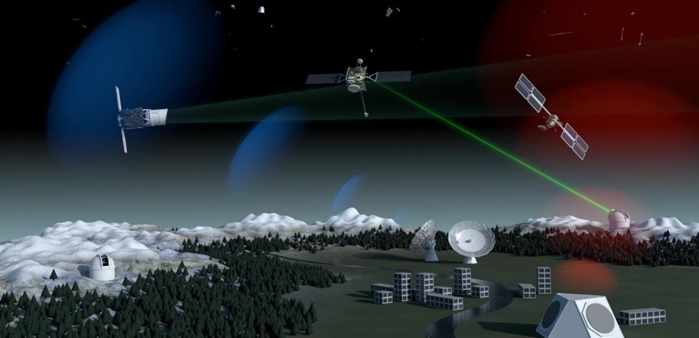Ground-based and space-based technologies are two primary methods used for monitoring space debris. Ground-based technologies involve using telescopes and radar systems to track the debris as it passes overhead. The telescopes are used to identify the debris visually, while the radar systems can detect the debris even when it is not visible to the naked eye. The data from these systems is then used to calculate the trajectory of the debris, predict its future location and assess the risk of collision with other objects. Space-based technologies are also used for monitoring space debris. Satellites equipped with cameras and sensors are used to observe and track the debris. The data collected is used to generate three-dimensional models of the debris, which are used to assess the risk of collisions and plan maneuvers to avoid the debris.

**Fig.5.1: ESA Ground based and space-based space debris monitoring technology** One example of a space-based technology is the Space-Based Telescopes for Actionable Refinement of Ephemeris (STARE) system developed by the US Air Force. STARE is a network of small satellites equipped with high-resolution cameras that provide real-time tracking of space debris. Another example is the European Space Agency's (ESA) Space Situational Awareness (SSA) program, which uses a combination of ground-based and spacebased sensors to track space debris and predict potential collisions.

## 5.2 REMOTE SENSING AND OPTICAL TRACKING SYSTEMS

Remote sensing and optical tracking systems are among the most commonly used technologies for monitoring and tracking space debris. These systems use radar, lidar, and optical sensors to detect and track debris in space.

Radar systems use radio waves to detect and track objects in space. They can operate day or night, and in all weather conditions, making them ideal for space debris monitoring. The United States Air Force Space Surveillance System (SSS) is a ground-based radar system that has been tracking space debris since the 1950s.

Lidar systems use laser beams to detect and track objects in space. They are particularly effective for tracking small debris particles and are commonly used in ground-based telescopes. The European Space Agency's Space Debris Telescope (SDT) is an example of a lidar system used for monitoring space debris.

Optical tracking systems use cameras to detect and track space debris. They are particularly effective for tracking larger objects and are commonly used in ground-based telescopes.

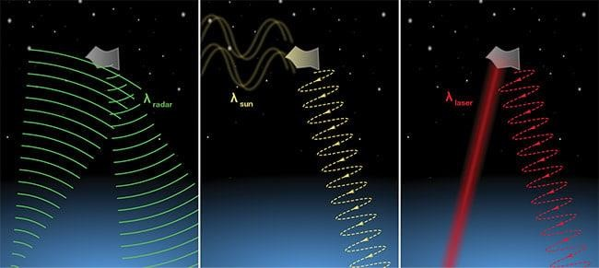

**Fig.5.2: optical imaging** *(center)***, radar imaging** *(left)* **and lidar** *(right)*

### 5.3 ADVANCEMENTS IN MACHINE LEARNING AND ARTIFICIAL INTELLIGENCE FOR SPACE DEBRIS MONITORING

Recent advancements in machine learning (ML) and artificial intelligence (AI) have opened up new opportunities for space debris monitoring and tracking. ML and AI techniques can be used to analyze large amounts of data collected from various sensors and satellites to identify patterns and anomalies in the behavior of space debris. Some of the applications of ML and AI in space debris monitoring include:

1. **Image and object recognition:** ML and AI techniques can be used to analyze images of space debris and recognize different types of debris, such as intact satellites, rocket bodies, and debris fragments.
2. **Prediction of collisions:** By analyzing the trajectories of space debris, ML and AI algorithms can predict the likelihood of collisions between debris and satellites or other debris, enabling timely maneuvers to avoid collisions.
3. **Orbit determination and tracking:** ML and AI techniques can be used to improve the accuracy of orbit determination and tracking of space debris, especially for small and faint objects that are difficult to detect using traditional methods.
4. **Debris classification and cataloging:** ML and AI algorithms can be used to classify space debris based on their size, shape, composition, and other characteristics, and maintain a catalog of debris in orbit around the Earth.



**Fig.5.3: ML and AI in space debris monitoring and tracking**

The use of ML and AI in space debris monitoring and tracking is still in its early stages, but has the potential to greatly enhance our ability to manage the growing problem of space debris.

**CHAPTER-6**

**CHAPTER 6**

**FUTURE OUTLOOK FOR SPACE DEBRIS MANAGEMENT**

**& CONCLUSION**

The problem of space debris is a complex and ongoing challenge that requires international cooperation and collaboration. Emerging trends and technologies, such as autonomous debris removal and in-orbit servicing, offer new opportunities for space debris management. However, there are also challenges to be addressed, such as the need for improved space situational awareness and the development of standards and regulations for space debris management.

### 6.1 EMERGING TRENDS AND TECHNOLOGIES FOR SPACE DEBRIS MANAGEMENT

As the issue of space debris continues to grow, there are several emerging trends and technologies that are being developed to address the problem. Some of these include

1. **On-Orbit Servicing (OOS):** This is a technology that involves the use of robots and other automated systems to perform maintenance and repair tasks on satellites and other spacecraft while in orbit. OOS can potentially extend the lifespan of these assets and reduce the need for new spacecraft launches, thereby reducing the amount of debris generated.
2. **Active Debris Removal (ADR) Technologies:** ADR technologies refer to techniques that actively remove debris from orbit. Some examples of ADR technologies include harpoons, nets, and robotic arms that can capture and remove debris. These technologies are still in the experimental phase, but they have the potential to significantly reduce the amount of debris in orbit.
3. **Improved Propulsion Systems:** Advanced propulsion systems are being developed that will allow satellites and other spacecraft to maneuver more efficiently and avoid collisions with other objects in orbit. For example, electric propulsion systems can be used to more precisely adjust a satellite's position and avoid collisions.
4. **Development of Debris-tolerant Designs:** Some companies and space agencies are designing spacecraft and satellites that are more resilient to collisions with space debris. This includes using materials that are more resistant to impacts and designing spacecraft with more redundancy in critical systems.

Overall, the future of space debris management will require a combination of these emerging trends and technologies, as well as continued international cooperation and commitment to addressing this critical issue.

### 6.2 NEED FOR INTERNATIONAL COOPERATION AND COLLABORATION

The issue of space debris is a global problem that affects all countries that are engaged in space activities. Therefore, there is a need for international cooperation and collaboration to address this issue. Several international organizations, including the United Nations Committee on the Peaceful Uses of Outer Space (UNCOPUOS), have been working to develop guidelines and policies for space debris mitigation and management. UNCOPUOS has developed a set of guidelines for the long-term sustainability of outer space activities, which includes recommendations for space debris mitigation measures.

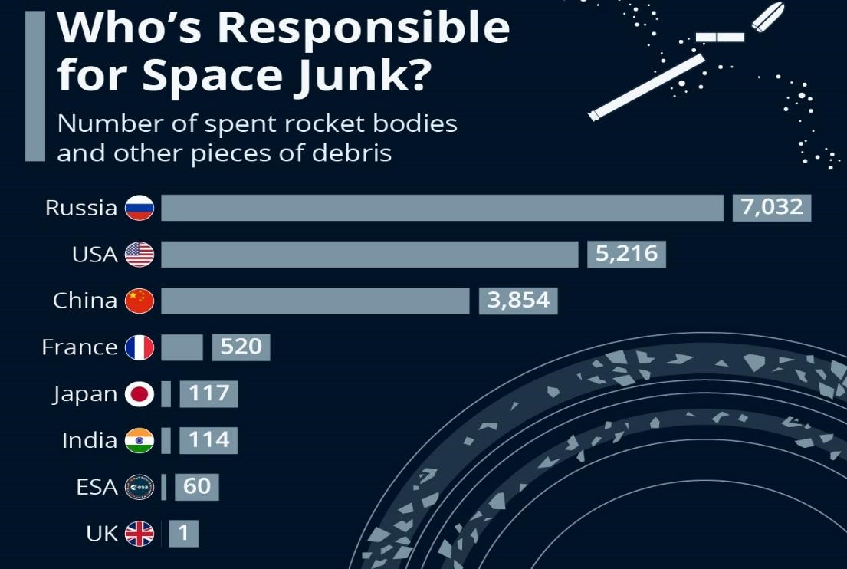

#### Fig.6.1: Countries & Space Junk

The Inter-Agency Space Debris Coordination Committee (IADC), which is a forum for international cooperation on space debris, has developed guidelines for the mitigation of space debris. There have been initiatives to foster international collaboration in the development of technologies for space debris monitoring and removal.

Overall, international cooperation and collaboration are crucial for the effective management of space debris. This includes the development of guidelines and policies, as well as the development of technologies for monitoring and removing space debris.

### 6.3 CHALLENGES AND OPPORTUNITIES FOR THE FUTURE OF SPACE DEBRIS MANAGEMENT

As the amount of space debris in Earth's orbit continues to grow, there are a number of challenges and opportunities that must be addressed in order to effectively manage this issue. Some of the main challenges and opportunities include:

1. **Funding:** One of the biggest challenges for space debris management is securing adequate funding. Space debris removal missions can be expensive, and it can be difficult to find funding sources for these efforts.
2. **International cooperation:** Space debris is a global issue that affects all countries with a space program. International cooperation is essential for effective management, but this can be challenging due to geopolitical tensions and differing priorities.
3. **Technology:** Advances in technology, such as machine learning and artificial intelligence, offer new opportunities for space debris monitoring and removal. However, developing and implementing new technologies can also be a challenge.
4. **Regulations:** While there are some international guidelines and policies in place for space debris mitigation, there is currently no binding international agreement on space debris management. Developing such agreements can be a challenge, but would provide a clear framework for managing space debris.
5. **Opportunities for innovation:** Space debris management presents opportunities for innovation and technological advancement. For example, developing new materials that are less likely to create debris, or developing new methods for removing debris from orbit.
6. **Increased awareness:** As more attention is given to the issue of space debris, there is an opportunity to raise public awareness and engagement. This can lead to increased support for funding and international cooperation efforts, as well as greater innovation and development of new technologies.

Overall, while there are significant challenges to effective space debris management, there are also many opportunities for innovation, international cooperation, and public engagement. By addressing these challenges and leveraging these opportunities, it may be possible to effectively manage the growing problem of space debris in Earth's orbit.

### 6.4 WOOD SATELLITES

Wood satellites, also known as "wooden satellites" or "tree satellites," are a proposed type of spacecraft that would be constructed from wood or other biodegradable materials. Wood satellites are a relatively new concept in satellite design and construction, and they offer several advantages over traditional metal and composite satellites. Wood satellites could play a role in reducing the amount of space debris and increasing sustainability in space. Traditional satellites are typically made of materials such as aluminum and titanium, which can be difficult to recycle and can contribute to the growing problem of space debris. Wood satellites, on the other hand, are made from a renewable and biodegradable material, which could reduce the environmental impact of space technology.

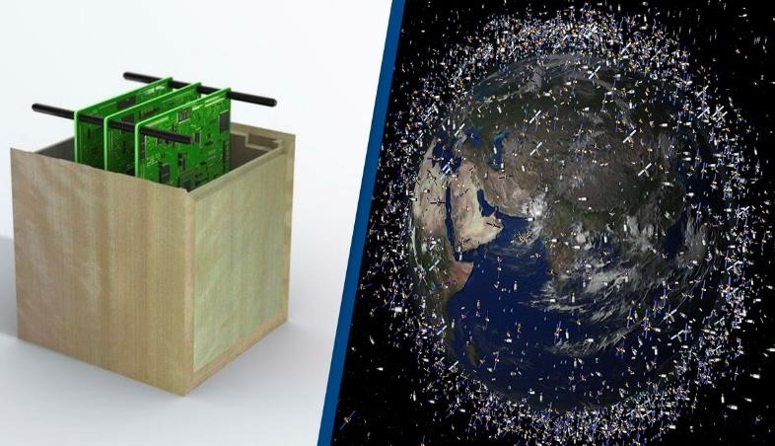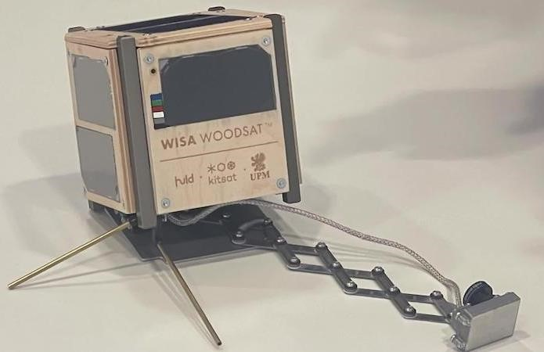

#### Fig.6.2: Wood Satellite

In 2020, the Japanese company Sumitomo Forestry announced plans to develop a wooden satellite by 2023.The first wood satellite, named WISA Woodsat, was launched into space on June 12, 2021, as a part of a rocket payload by the New Zealand-based spaceflight company Rocket Lab.The satellite is a cube measuring 10x10x10 cm, and it carries a variety of instruments for testing and demonstrating new space technologies.

One of the main benefits of wood satellites is their potential to reduce space debris. Unlike traditional satellites, which often remain in orbit indefinitely after they are no longer functional, wood satellites are designed to burn up harmlessly in the Earth's atmosphere at the end of their useful life. This makes them a more sustainable option for space technology.

### 6.5 CONCLUSION

#### 6.5.1 SUMMARY OF THE PROBLEM OF SPACE DEBRIS AND ITS IMPACT

Space debris is an accumulation of man-made objects in space that no longer serve any useful purpose. This debris is primarily composed of inactive satellites, spent rocket stages, and fragments from collisions or explosions. The growth of space debris poses a significant threat to the operation of operational satellites, as well as the safety of human activities in space. Collisions between space debris and operational satellites can cause severe damage, which can lead to the loss of valuable assets and critical services. The accumulation of space debris also increases the risk of the Kessler Syndrome. This poses significant economic and environmental consequences, as the loss of operational satellites could impact critical services such as weather forecasting, global communication, and navigation systems.

#### 6.5.2 IMPORTANCE OF INTERNATIONAL COOPERATION COLLABORATION IN ADDRESSING THE PROBLEM OF SPACE DEBRIS

The problem of space debris is a global issue that requires international cooperation and collaboration. Space debris is not confined to any single country or region, and its impact can affect the entire world. Therefore, it is essential that countries work together to address the problem and develop effective solutions.International cooperation is necessary for sharing information and data about the current state of space debris, as well as for developing and implementing policies and guidelines for space debris mitigation. International organizations such as the United Nations and the International Astronautical Federation have been instrumental in promoting cooperation and collaboration among countries. International cooperation is necessary for addressing the legal and regulatory aspects of space debris. The Outer Space Treaty, which is the fundamental legal framework governing space activities, requires countries to ensure that their space activities do not cause harmful interference or produce space debris.

In summary, international cooperation and collaboration are essential for addressing the problem of space debris. Only by working together can countries develop effective solutions and ensure the safety and sustainability of space activities for the benefit of all.

#### 6.5.3 CONCLUSION

Space debris is a significant problem that poses risks to operational satellites and human activities in space. The origins and growth of space debris have been identified, and it is clear that the problem is only getting worse. The increasing amount of debris in orbit makes collision risks and the Kessler Syndrome a major concern. Therefore, there is a need for effective space debris management strategies, including techniques for removing debris and controlling its growth. Active debris removal techniques, such as harpoons, nets, and robotic arms, are being developed and tested, while passive techniques, such as deorbiting and orbital disposal, are already in use. Additionally, emerging technologies, such as machine learning and artificial intelligence, are improving space debris monitoring and tracking capabilities. However, addressing the problem of space debris requires international cooperation and collaboration among governments, space agencies, and commercial entities. With the development of innovative techniques and technologies, and increased international cooperation, we can ensure the sustainability and safety of space activities for current and future generations.

### BIBILOGRAPHY

1. Alby, E., Anselmo, L., & Casalino, M. (2019). Active Space Debris Removal: A Comprehensive Technical Review. Journal of Spacecraft and Rockets, 56(4), 915-928.
2. Baerwald, P., & Liou, J. C. (2016). NASA orbital debris program office’s optical measurements of large orbital debris. Acta Astronautica, 128, 160-173.
3. European Space Agency. (2017). Space debris mitigation handbook. Retrieved from https://www.esa.int/Safety_Security/Space_Debris/Space_debris_mitigation_handbook
4. Johnson, N. L., & Liou, J. C. (2016). Overview of NASA’s orbital debris mitigation efforts. Acta Astronautica, 128, 54-68.
5. Klinkrad, H. (2013). Space debris: Models and risk analysis. Berlin: Springer.
6. Liou, J. C. (2007). Orbital debris: A technical assessment. Berlin: Springer.
7. Liou, J. C. (2016). NASA’s current and future space debris mitigation guidelines. Acta Astronautica, 128, 69-75.
8. National Aeronautics and Space Administration. (2021). Orbital debris. Retrieved from https://www.nasa.gov/mission_pages/tdm/orbitaldebris/index.html
9. United Nations. (2019). Space debris mitigation guidelines of the committee on the peaceful uses of outer space. Retrieved from

https://www.unoosa.org/documents/pdf/spacelaw/sd/Space_Debris_Mitigation_Guidelines_EN.pd

f

1. United Nations Office for Outer Space Affairs. (2021). Space debris. Retrieved from https://www.unoosa.org/oosa/en/ourwork/topics/space-debris.html